Experiment-7

***Steady- state performance of a 1-phase transformer***

***Objective:*** Obtain equivalent circuit parameters by conducting open-circuit, short-circuit and resistance measurement tests. Theory

A single phase transformer essentially consists of two magnetically coupled windings capable of transforming the voltage and current level of the alternating supply to different values. The two windings, one called the input or the primary winding and the other called the output or the secondary winding are placed on a same core made of silicon steel stampings. The core provides a low reluctance path for the alternating magnetic flux, which links both the windings.

If we assume the pulsating flux Ф to have a sinusoidal waveform ФmCosωt, where ω is the supply frequency in radians per second, the induced primary voltage is given by

E1 = -N1dФm/dt …. (1.1)

Where, N1 is the number of primary turns.

Thus the primary RMS induced voltage E1 is proportional to the primary turns N1 and lags behind the flux by 90º. Since the flux Фm also links with the secondary turns and is in phase with E1.

E1/E2 = N1/N2 ……(1.2)

Now, E1 opposes the applied voltage say VI and is nearly equal to VI if the primary resistance and leakage reactance is very small. Figures 1.1 and 1.2, 1.3 and 1.4 respectively show the equivalent circuit and phasor diagram of a single phase transformer.

Now with the primary resistance and leakage inductance neglected, we have

E1 = V1 ……(1.3)

E2 = V2…..(1.4)

Since E2/E1 = N2/N1, we can say that V2/V1 = N2/N1. Thus approximately the output voltage bears the same ratio to the input voltage, which secondary turns bear to the primary turns.

So far the secondary has been considered open circuited. If it is loaded, a current I2 will flow through the load and secondary winding. The effect of this current is to reduce the flux Фm according to lenz’s law. This decreases the induced emf E1. The current now rushes from the primary supply to cancel the effect of the secondary current and to establish equilibrium flux Фm. Thus the power has been transferred from the primary to the secondary winding through the mutual flux. Now ignoring the losses one can say that output power is equal to the input power. Thus

I2E2 = I1E1

I2/I1 = E1/E2 = N1/N2…..(1.5) Therefore the current ratio is equal to the inverse of the voltage turns ratio. This situation in the phasor diagram where I2’ is shown to balance the effect of I2 and the total input current on load become I1. The phasor diagram can now be modified to include the effect of resistance and leakage reactances of the windings.

It is well known that the equivalent circuit of a single phase transformer can be approximately represented as shown in Fig.1.2. The parameters R0 and X0, which take into account the two components of no load current, can be determined by conducting OPENCIRCUIT test. The parameter R1 and X1 are determined by SHORT-CIRCUIT test. These parameters depend to a certain extent on the actual load conditions of the transformer.

***Equipment and Components***

(a) One 1-ϕ transformers of identical ratings. (b) One 1-ϕ auto-transformers. (c) One low pf watt meters. (d) One a.c. ammeters. (e) One a.c. voltmeters.

***Procedure, Connection Diagrams, Experimentation and Precautions*** Note down the name plate details of the transformer and identify terminals. Observe the windings and constructional features.

OPEN-CIRCUIT Test

The open circuit test is usually done on the LOW-VOLTAGE side, keeping the HIGH-VOLTAGE side open. Make connections as shown in Fig. 1.5. Apply rated voltage V0 and note the corresponding power input (W0) and current drawn (I0). Repeat the above for different input voltages and tabulate the readings as shown in Table.1.1.

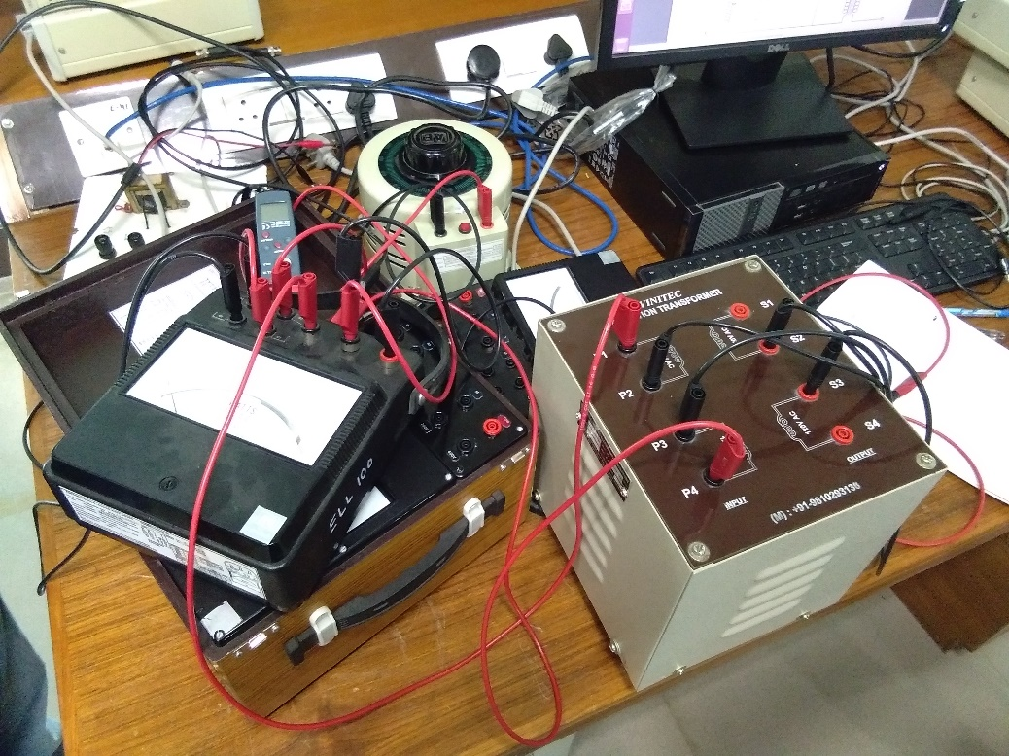

Snapshot of breadboard with circuit connected as in Fig. 1.5 in manual

SHORT-CIRCUIT Test

The short circuit test is usually done on the HIGH-VOLTAGE side, keeping the LOW-VOLTAGE side short-circuited. Make connections as shown in Fig.1.5. Apply the required voltage (VSC) so that the current drawn (ISC) is equal to the rated current. Note the corresponding power input (WSC). Repeat the above for different values of short circuit currents and tabulate the readings as in Table.1.2.

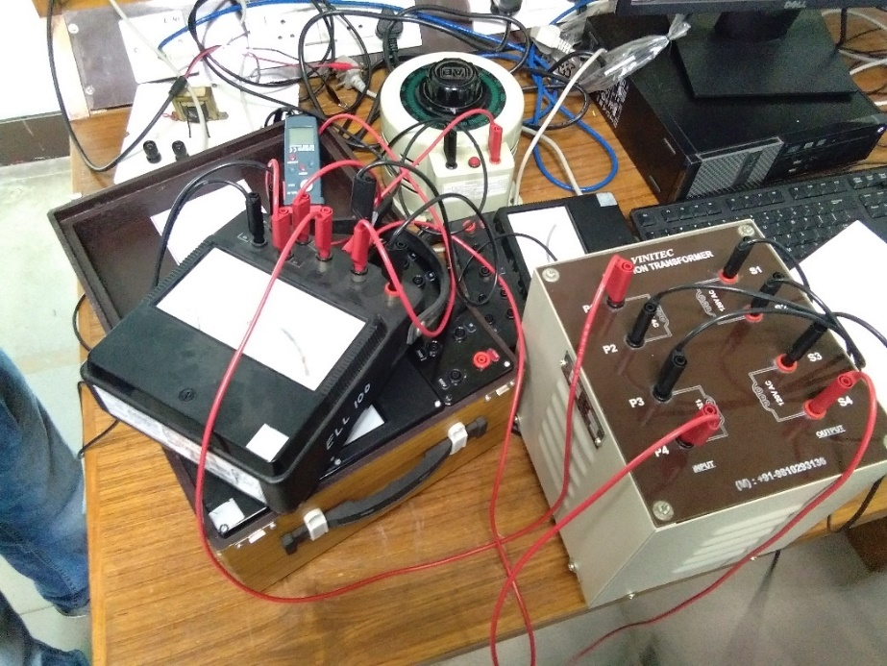

Snapshot of breadboard with circuit connected as in Fig. 1.6 in manual

***Observation******Table:***

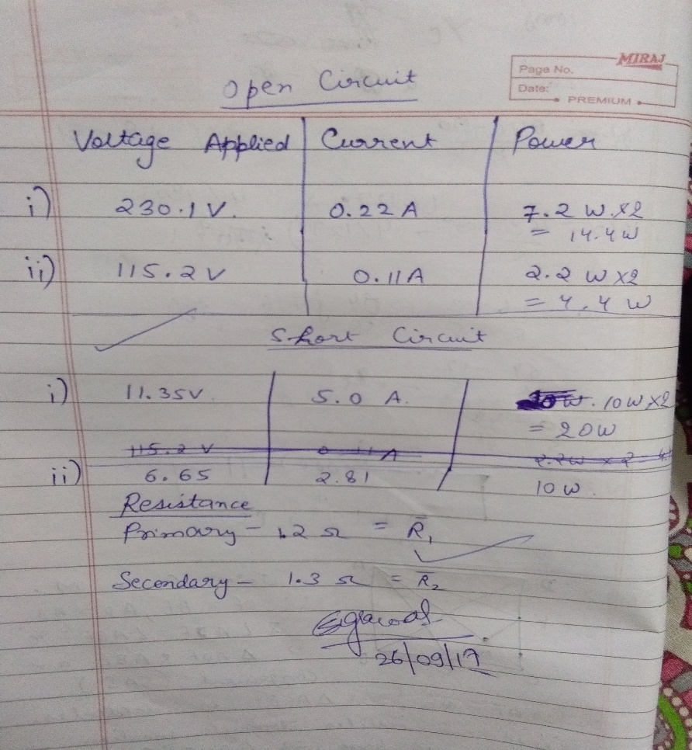

Measured current and wattage for at least two different input voltages and Measured current and wattage for at least two different values of short-circuit current

Determination of the Coefficient of Coupling

Measure the resistance of primary winding (R1) and secondary winding (R2) by using a low voltage/ battery supply. Conduct OPEN-CIRCUIT test on the primary side (for rated voltage) with a voltmeter connected to the secondary side. Note the OPEN-CIRCUIT input voltage (V10), input current (I10), and the secondary induced voltage (E20) and tabulate as shown in Table.1.3. Now, short circuit the secondary windings and supply the required voltage on the primary side so that the short circuit current is equal to the rated current. Note the corresponding voltage (V1SC) and current (I1SC) and tabulate as shown in Table.1.3.

**Data Sheet**

1-ϕ transformer:

KVA rating:

Primary voltage:

Secondary voltage:

Frequency:

**Determination of Coefficient of Coupling**

Resistance of primary winding (R1) = ……ohms

Resistance of secondary winding (R2) = …….ohms

**Data Processing and Analysis**

Losses

Iron loss (for rated voltage) = …………Watts

Full load copper loss = …………Watts

Equivalent Circuit Parameters

The four parameters of the equivalent circuit are R0, X0, R1 and X1 (see Fig.1.1).R0 and X0 are obtained from OPEN-CIRCUIT test and R1 and X1 are obtained from the SHORTCIRCUIT test as follows:

Calculation

From OPEN-CIRCUIT test,

No load p.f. (cosϕ0) = W0/V0I0) = ……….

∴ sin ϕ0 = ……….

IW= I0cosϕ0= ……….amps

Iµ = I0 sin ϕ0= ……….amps

R0 =V0/IW = ……..ohms

X0 = V0/Iµ = ……..ohms

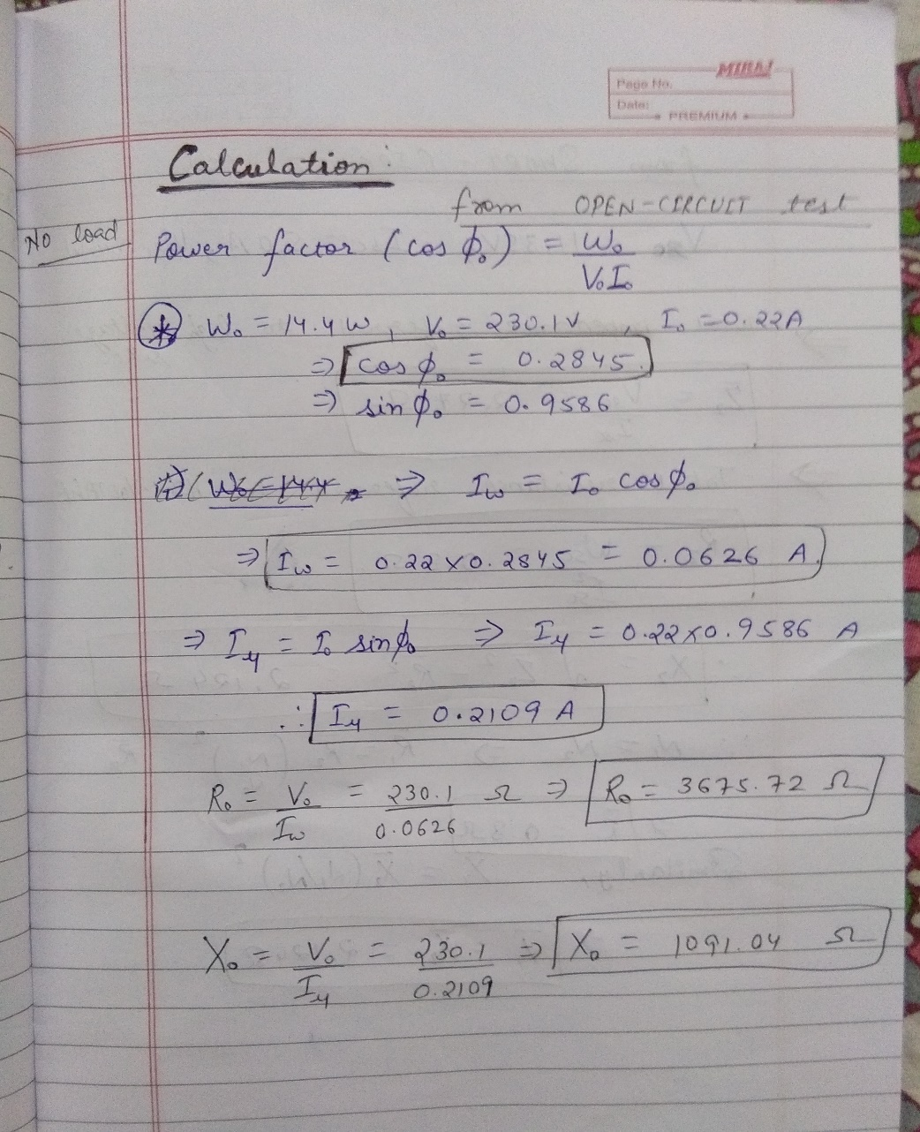

From SHORT-CIRCUIT test,

Total impedance referred to HIGH-VOLTAGE side (sec. side),

Z 2= VSC/ISC= ……..ohms

Total resistance referred to HIGH-VOLTAGE

R2= WSC/ISC2 = ……..ohms

∴

22 222 X Z R =− = ……..ohms

∴ Total resistance referred to LOW-VOLTAGE side (primary),

R1= R2(N1/N2)2= ……..ohms

Similarly X 1= X 2(N1/N2)2= ……..ohms

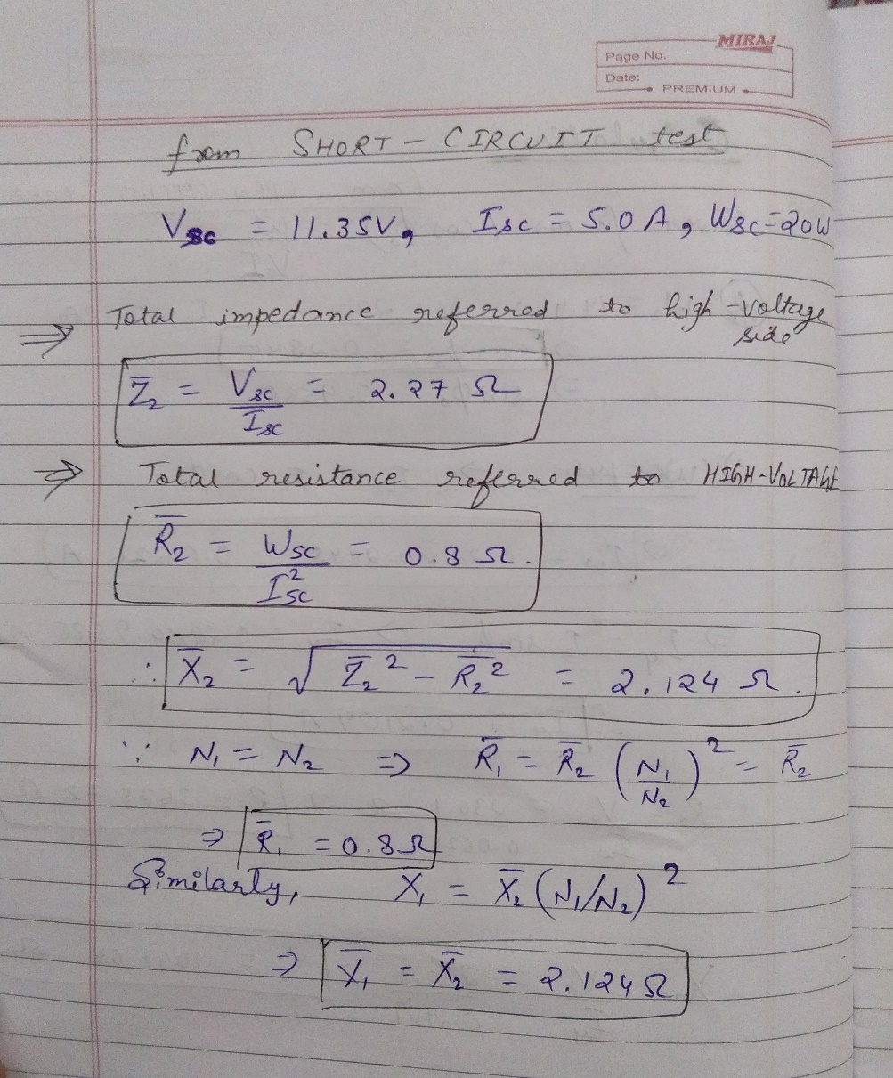

Coefficient of Coupling (K)

Self-impedance of primary winding, Z11 = R1+ jωL11= V10/I10 = ……..ohms

Resistance of the primary winding (R1) = ……..ohms

∴X11 = jωL11 = 22 11 1 ZR − = ……..ohms

∴ L11 = ……..henry

Now, E20 = ( jωL12) · I10

∴ Z12 = jωL12 = E20/I20 = ……..ohms

∴ L12 = ……..henry

Let Z22 = R2 + jωL22

The driving point impedance of the primary winding with the secondary winding shorted is, ZSC = V1SC/ISC = ……..ohms

It can be shown that ZSC = Z11- Z122/Z22, where - Z122/Z22 is called the reflected impedance of the secondary circuit. ∴ Z22 = ……..ohms, R2 = ……..ohms

X22 = 22 22 2 ZR − = ……..ohms

∴ L22 = ……..henry ∴ K = L12/ 11 22 LL ⋅ = ……..

***Conclusion:***

From the above experiment, we have been able to calculate the various circuit parameters of a real transformer using the open circuit and short circuit tests. Through this experiment we were introduced to the single phase transformer circuit and its operations. This helped me to know the actual working of a transformer and its underlying principle. The various types of losses (flux loss, iron loss) hints the deviation from expected results.

Thus this lab report contains the theory, observations and calculations of various circuit parameters of a single phase transformer.

The various circuit parameters are

cosɸ=0.2845

Iw=0.626

Iµ=0.2109

Ro=3675.72Ω

Xo=1091.04Ω

Z2=2.27Ω

R1=R2=0.8Ω

X1=X2=2.124Ω.